Project Development - Database design

## E-R Diagram Design:

Link : <https://www.datanamic.com/dezign/erdiagramtool.html>

## E-R Diagram E represents the Entity and R represents the relationship between them.

Entity : Table (collection of data in the form of Rows and Columns)

Columns can be called Attributes and rows can be called as Tuples

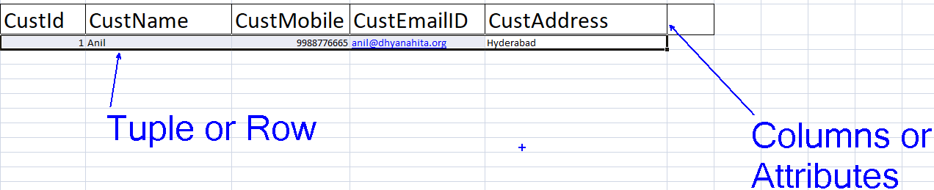

E- R Diagram for User Module

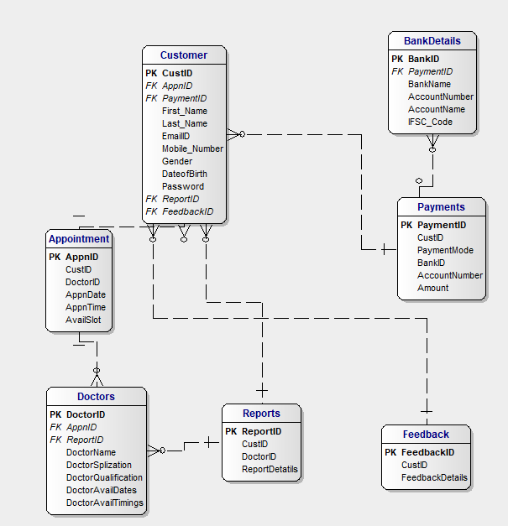

E- R for Administrator Module:

